Protocol # | Description | Purpose | Reqt/Spec | Author
Emp003 | Delete Employee Record | To verify that the User can Delete Employee Record Successfully. |  | Saurabh Pawar

Prerequisites | - Standard System Configuration.  - The user must be logged In to the web interface.  - The user must have local and system admin privileges.  - The employee should not be listed in document routes.
Procedure | - Login to the web interface.  - Click on Administration link from the top right menu.  - Click on employee link.  ER 1 – Employee records are listed.  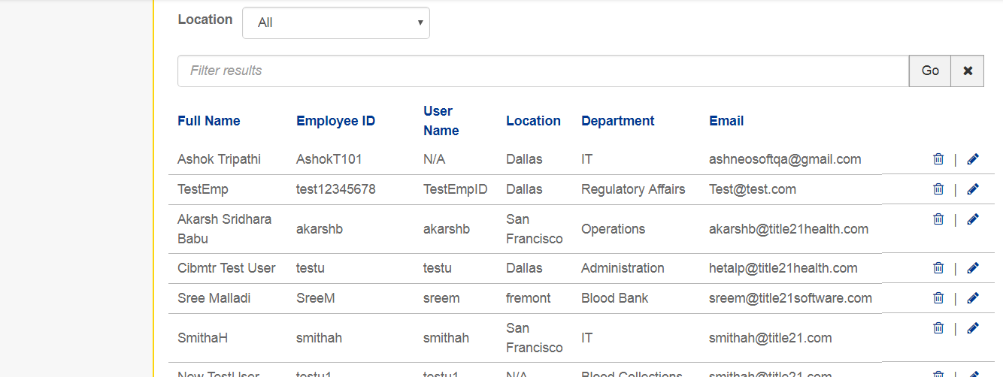  - Click on Delete Employee icon.  ER 2– “Delete Employee” popup is displayed  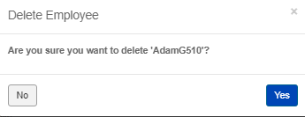  - Click on No Button.  - Search for employee  ER 3 – The employee is not deleted.  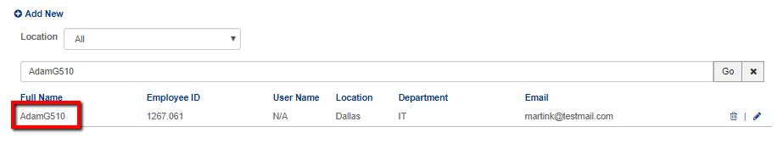  - Click on the delete icon against the employee in the previous step.  - Click on Yes Button when the confirmation dialog is displayed.  ER 4 – Employee should get deleted and show a confirmation message.  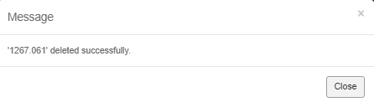  - Search for the employee which was deleted in the previous step.  ER 5 – Employee is no longer available in the list.  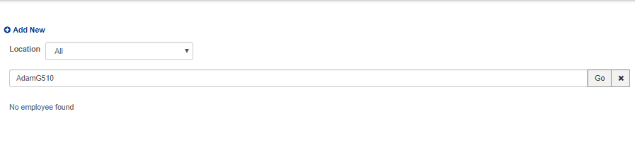
Pass/Fail | Pass:  Fail: | Type of Execution:
Pass/Fail | Pass:  Fail: | Automation: | Manual:
Notes/Deviations
Additional Remarks in case of Manual Execution
Name of Tester(if Manual)
Test Case Review/Approval | Signature of  Reviewer/Approver: |  |  | Date of Approval:

